Name: Devang Dedhia Department: CYSE
Div: BE-15 Roll No: 66

Subject: Mobile Forensics

Experiment No: 1
Date of  Performance: | 23/01/2025
Date of Submission: | 30/01/2025
Program formation/ Execution/ ethical  practices (06) | Timely Submission (01) | Viva Answer (03) | Total Experiment Marks  (15) | Teacher Signature with date

Experiment No. 1
Aim: Mobile phone Evidence Extraction Process, Practical mobile forensic approaches
Lab outcome: Explore fundamentals of Practical mobile forensics.

Theory:
Data acquisition is the process of imaging or otherwise extracting information from a digital device and other attached media. Acquiring data from a mobile phone is not as simple as a standard hard drive forensic acquisition. The following points break down the three types of forensic acquisition methods for mobile phones: physical, logical, and manual. These methods may have some overlap with a couple of levels discussed in the mobile forensics tool leveling system. The amount and type of data that can be collected will vary depending on the type of acquisition method being used.

Physical acquisition of a mobile device is nothing but a bit-by-bit copy of physical storage. With direct access to flash memory, information can be acquired from the device through physical extraction. Flash memory is non-volatile memory and is primarily used in memory cards and USB flash drives as solid-state storage. The process creates a bit-for-bit copy of an entire filesystem, similar to the approach taken in computer forensic investigations. Physical acquisition is able to acquire all of the data present on a device, including the deleted data, and access to unallocated space on most devices
Manual acquisition in mobile phones, physical acquisition is usually the best option, and logical acquisition is the second-best option. Manual extraction should be the last option when performing the forensic acquisition of a mobile phone. Both logical and manual acquisition can be used to validate findings in physical data. During manual acquisition, the examiner utilizes the user interface to investigate the contents of the phone's memory. The device is used normally through keypad or touchscreen and menu navigation, and the examiner takes pictures of each screen's contents. Manual extraction introduces a greater degree of risk in the form of human error, and there is a chance of deleting evidence. Manual acquisition is easy to perform and only acquires the data that appears on a mobile phone
A logical acquisition captures a part of what is accessible to the user; in other words, what is included in an iTunes backup. It means that we won't get any deleted files, but, thanks to SQLite databases' free lists and unallocated space, we can recover deleted records, including SMS and other chats, browsing history, and so on.
Logical acquisition is the simplest way to ascertain whether the device is unlocked as it simply uses the built-in backup mechanism. Most tools and methods that support the logical acquisition of iOS devices will fail if the device is locked. Some think that if a physical image is captured,

there is little to no need for a logical acquisition. However, not all data is parsed in a physical image, which is why having access to a logical image, which results in readable data, will assist you in digging deep into the physical image for artifacts to support your forensic investigation.
Logical acquisition is the fastest, easiest, and cheapest way to gain access to data stored on a mobile device. There are a variety of tools, ranging from commercial to free, that are capable of capturing logical images. Most of these tools require that the device be unlocked, or access to the listed file from the host machine be readily available

Procedure & Output:
Practical logical acquisition with the Belkasoft Acquisition Tool

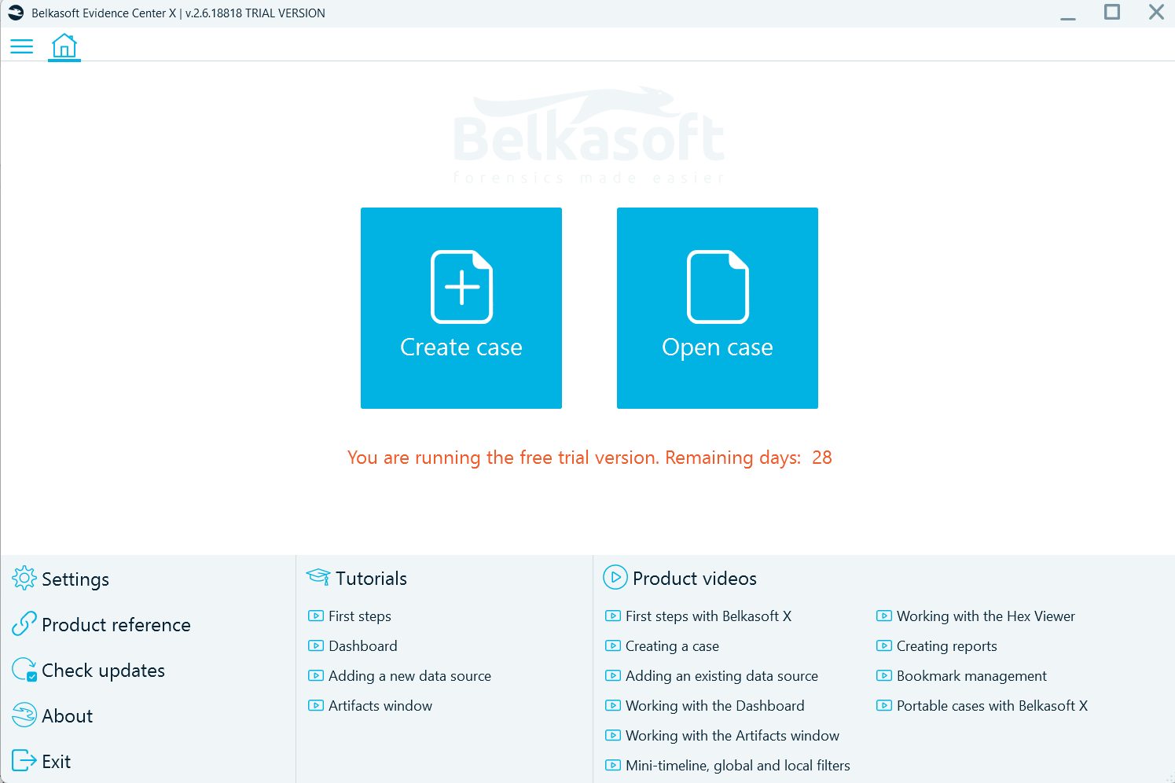
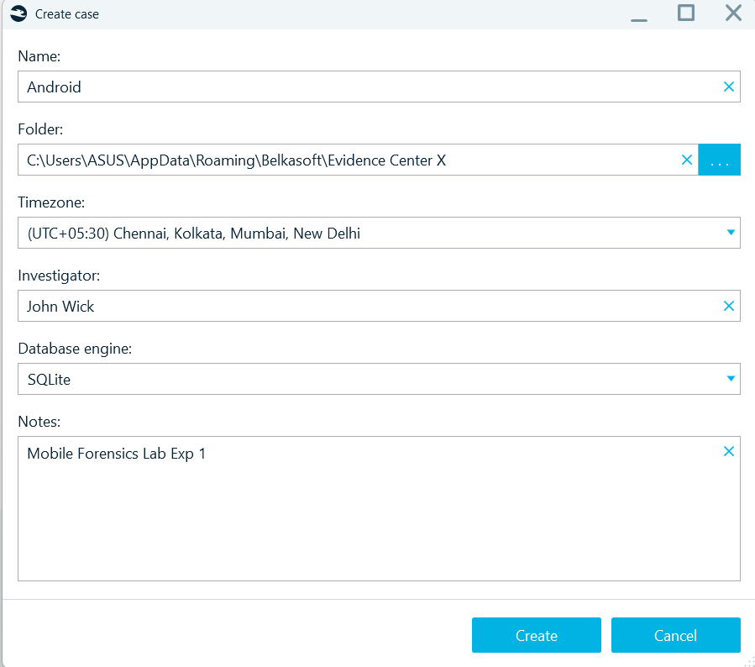

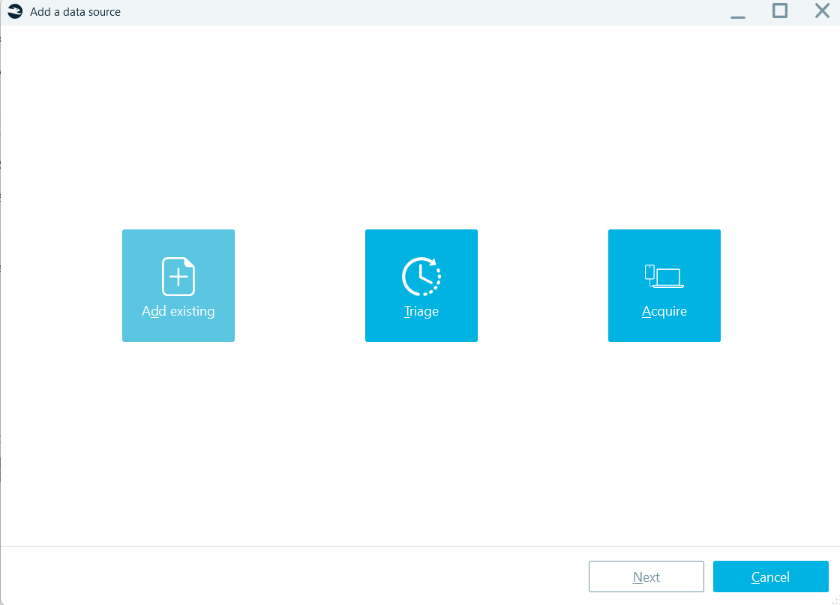

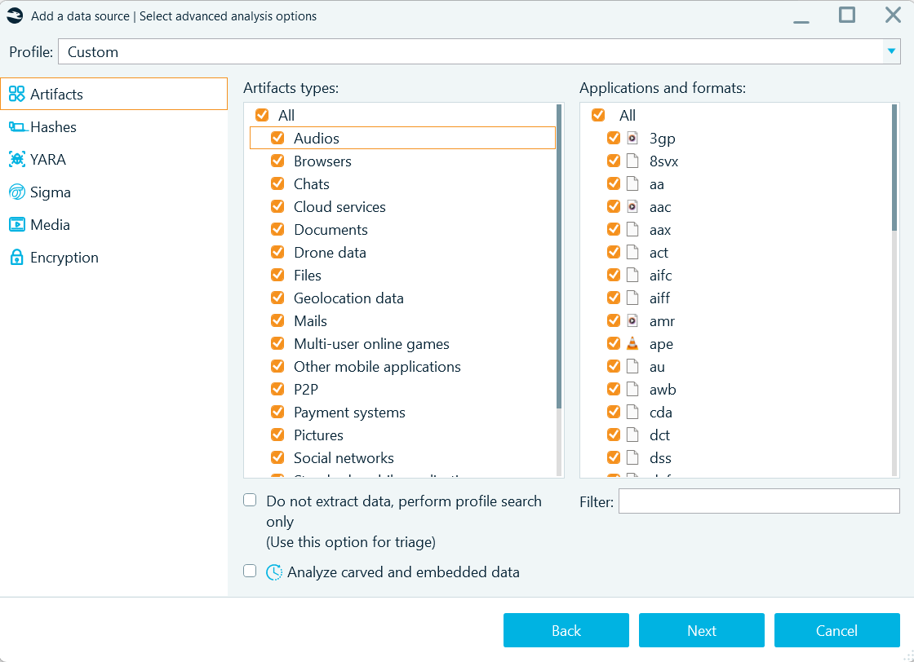

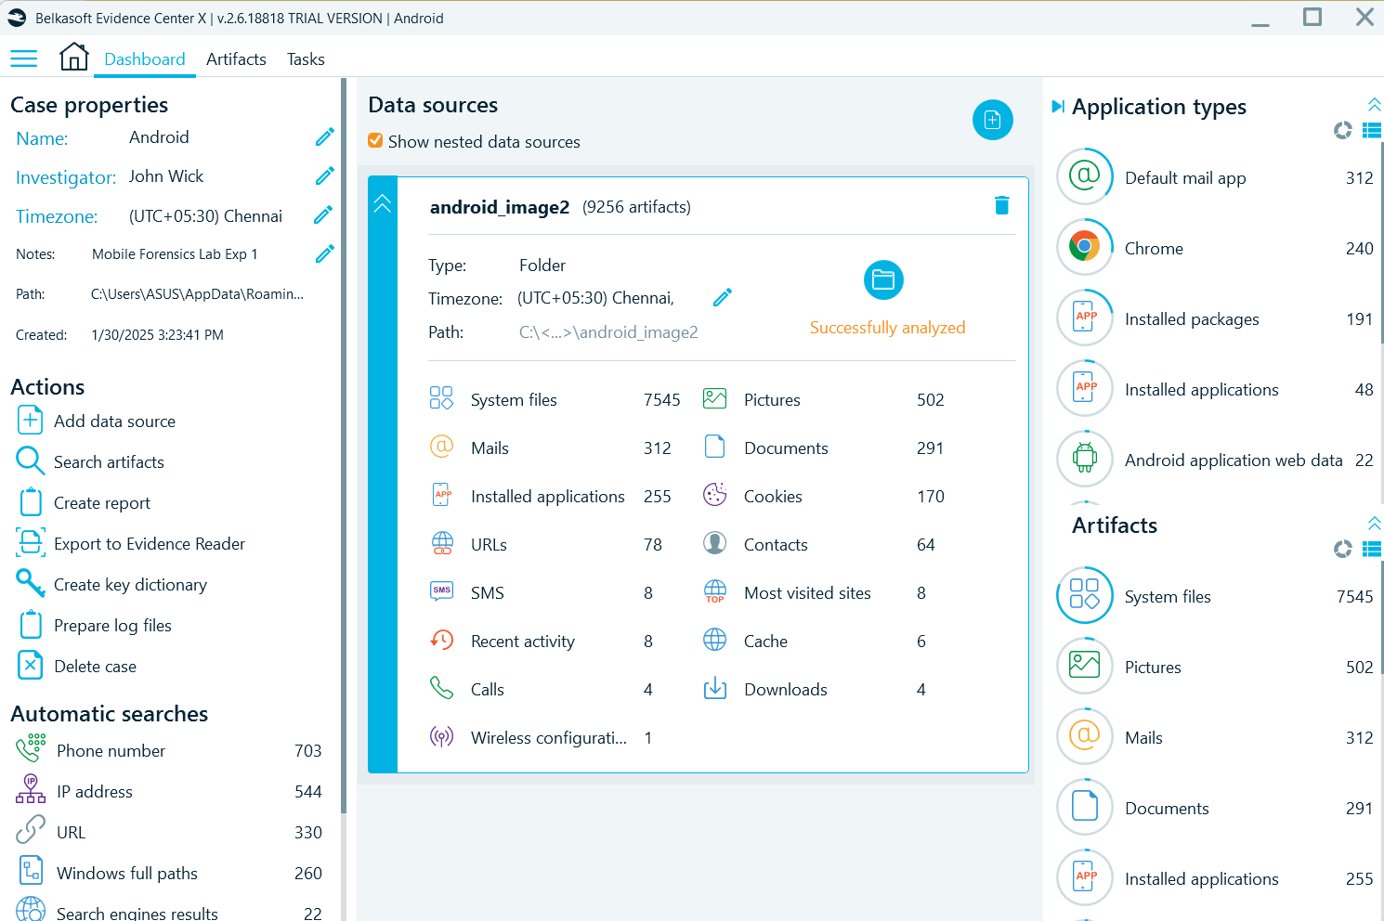

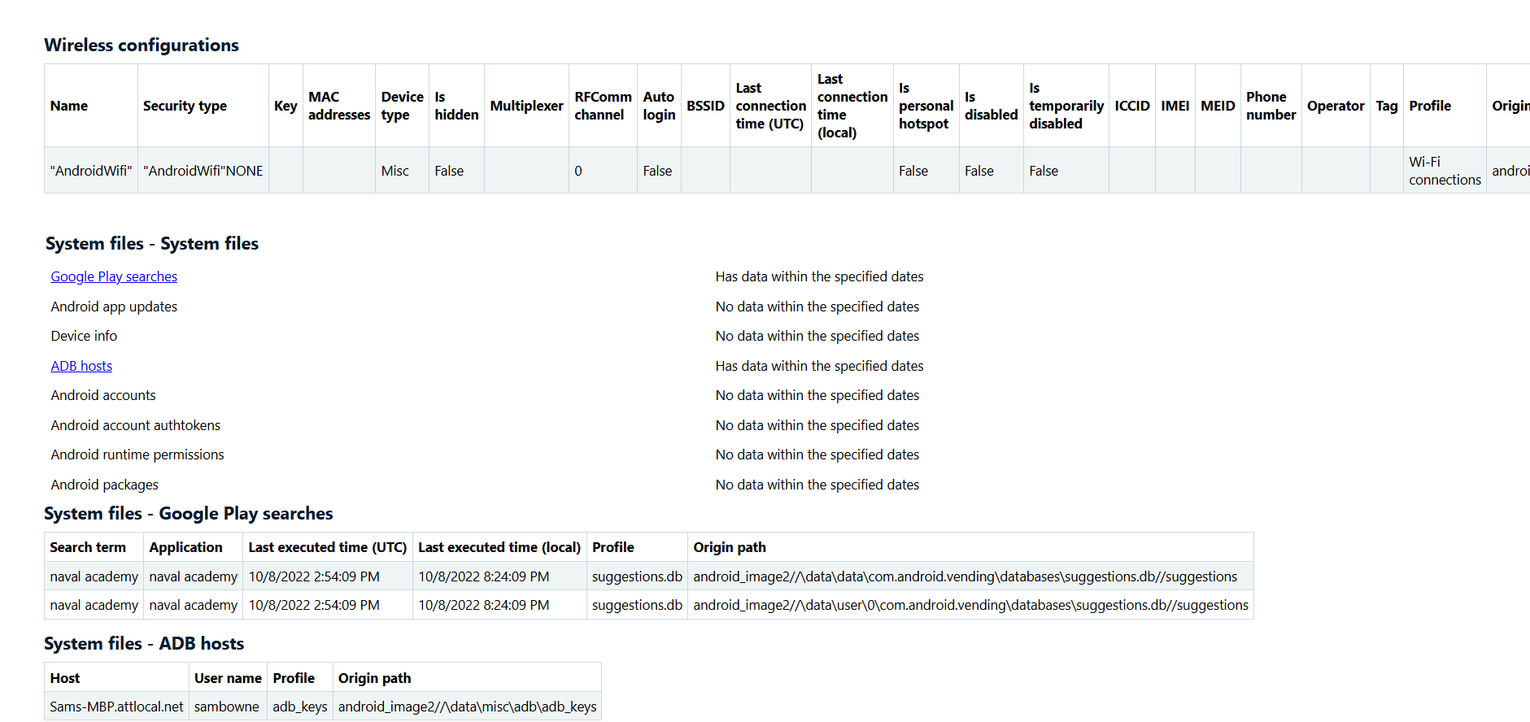

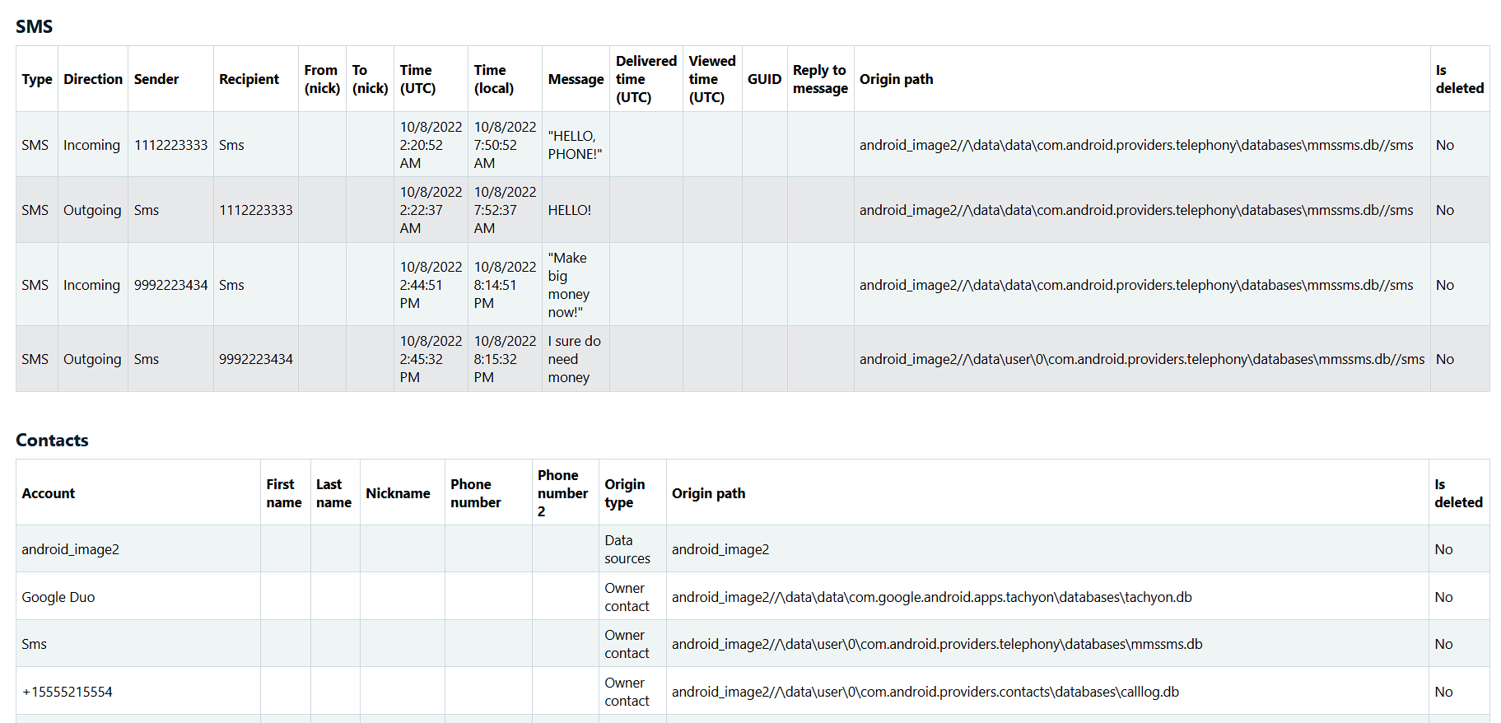

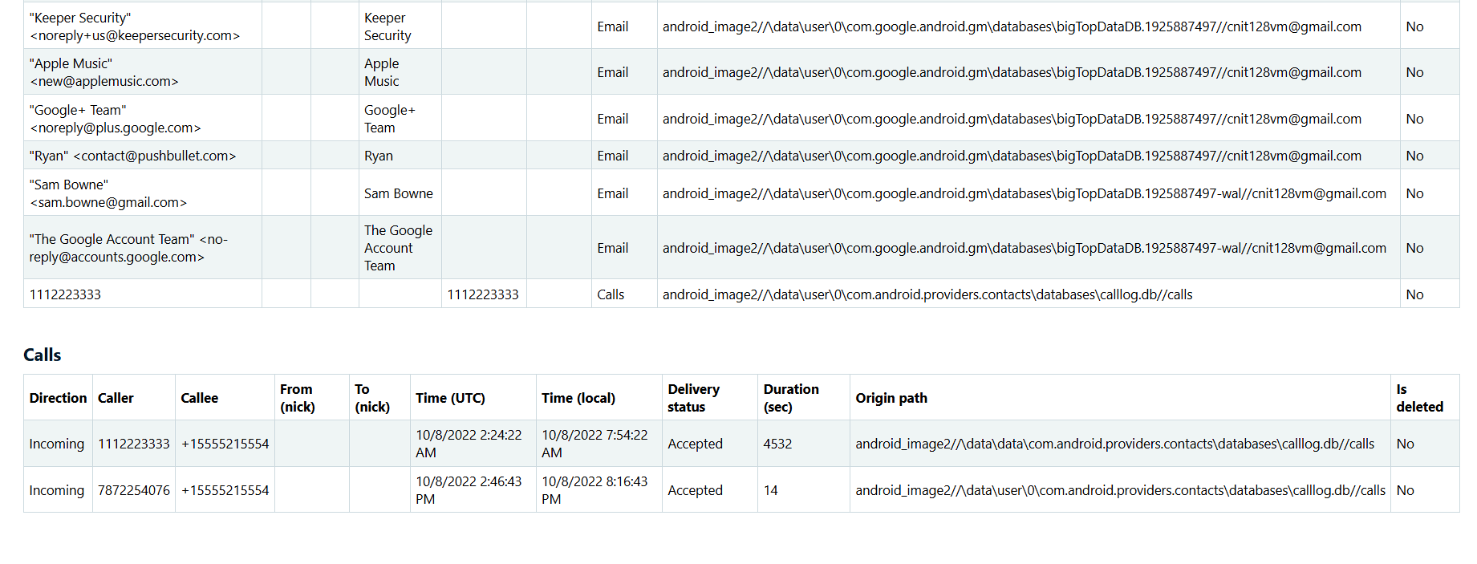 Conclusion:
We have performed evidence extraction on both Android devices using Belkasoft Acquisition Tool.

